

**<< TITLE OF REPORT >>**

**<< YOUR NAME >>**

**<YOUR STUDENT NUMBER >>**

**This project report is submitted in partial fulfilment of the requirements for the degree of MSc in << YOUR PROGRAMME >>**

**University of Stirling**

**<< DATE >>**

# Acknowledgements

<< ANY ACKNOWLEDGEMENTS YOU WISH TO MAKE GO HERE. ALSO ACKNOWLEDGE THAT THE PROJECT WAS UNDERTAKEN IN ACCORDANCE WITH THE ETHICS FRAMEWORK OF THE UNIVERSITY OF STIRLING*.* >>

# Executive Summary

<< A ONE-PAGE SUMMARY OF CONTENTS OF REPORT. COMPULSORY AND WRITTEN FOR LAY AUDIENCE>>

**Table of Contents**

Acknowledgements i

Executive Summary ii

List of Figures vi

List of Abbreviations Used vii

Terminology viii

Chapter 1 – Introduction 1

1.1 Background 1

1.2 Problem Statement and Justification 1

1.3 Aim 1

1.3.1 Objectives 1

1.4 Research Questions 1

1.5 Expected Audience and Benefits of Project 1

1.6 Report Structure 1

Chapter 2 – Problem Exploration and Analysis 2

2.1 Introduction 2

Key Terms and Their Relevance 2

2.2 Problem Exploration 3

Accounts Receivable Credit Analysis 3

Accounts Receivable Debit Analysis 3

Expenses Analysis 3

Daily Account Balance Analysis 4

Help Desk Data Analysis 4

2.3 Tools Being Used To Address the Issues 4

Power BI 4

Excel 4

Python 5

Critique of Methods 5

2.4 CRISP-DM Methodology 5

CRISP-DM Overview 5

Application to the Case Study 5

2.5 Conclusion 6

Chapter 3 – Methodology 7

3.1 Introduction 7

3.2 Methodology Overview 7

Objectives 7

Tools and Techniques 7

3.3 Data Collection and Preparation 7

Data Sources 7

Data Cleaning and Transformation 7

Data Transformation 8

3.4 Analytical Approach 8

Exploratory Data Analysis (EDA) 8

KPI’s Analysis 8

Data Visualization 8

3.5 Deployment and Reporting 8

Reporting Results 8

Recommendations and Implementation 9

3.6 Conclusion 9

Chapter 4 – Results and Discussions 9

4.1 Introduction 9

4.2 Analysis and Findings 10

Assessment of the ALL Expenses Data 10

Assessment of Accounts receivable Data 11

Assessment of Daily Account Balances Data 13

Assessment of HR Helping Desk Data 15

Assessment of Invoice Data 16

Assessment of Mailbox Data 17

Assessment of Revenue Monitoring Committee Report Data 19

Assessment of Customer Accounts Aging by bucket List Data 20

Assessment of Absentees Data 22

Assessment Sickness Absentees Data 24

Conclusion 25

Chapter 5 – Conclusions, Limitations and Recommendation 26

5.1 Conclusions 26

Financial Performance: 26

Expense Management: 26

Daily Account Balance Monitoring: 26

Aging and Balance Data: 26

Help Desk and Absenteeism Data: 26

5.2 Limitations 27

Data Integration Challenges: 27

Data Quality and Completeness: 27

Limitation in Methadology 28

Constraints in Data Availability 28

Interpretative Constraints 28

5.3 Recommendations 28

Strengthen Debt Collection Strategies: 29

Optimize Expense Management: 29

Improve Financial Stability through Enhanced Balance Monitoring: 30

Address Absenteeism with Targeted Interventions: 30

Enhance Help Desk Efficiency: 31

Improve ERP System Integration and Data Management: 31

5.4 The Future 32

Embracing Technological Advancements: 32

Continuous Improvement and Adaptation: 32

Enhancing Data Integration and Analytics: 32

Fostering a Data-Driven Culture: 32

Strategic Planning and Long-Term Vision: 33

Leveraging Feedback and Lessons Learned: 33

Bibliography 34

APPENDICES 35

## List of Figures

Figure 1 Expenses Dashboard 10

Figure 2 Accounts Receivable Credit Dashboard 11

Figure 3 Accounts Receivable Debit Dashboard 12

Figure 4 Daily Accounts Balance Dashboard 13

Figure 5 HR Helping Desk Dashboard 15

Figure 6 Invoice Data Dashboard 16

Figure 7 Mailbox Dashboard 17

Figure 8 Revenue Monitoring Committee Report Dashboard 19

Figure 9 Customer Accounts Aging by bucket List Dashboard 20

Figure 10 Absentees Dashboard 22

Figure 11 Sick Absentees Dashboard 24

# List of Abbreviations Used

<< LIST ANY ABBREVAITIONS YOU USE IN THE REPORT >>

# Terminology

<< LIST ANY TECHNICAL WORDS AND THEIR DEFINITIONS HERE, FOR EASE OF USE >>

# Chapter 1 – Introduction

# 1.1 Background

<< SET THE SCENE IN WHICH THE PROJECT TOOK PLACE – USE CRISP-DM STAGE 1 IF APPLICABLE >>

## 1.2 Problem Statement and Justification

<< STATE THE PROBLEM YOU ARE ADDRESSING AND JUSTIFY ITS IMPORTANCE >>

## 1.3 Aim

<< STATE THE AIMS OF THIS PROJECT WORK >>

### 1.3.1 Objectives

<< STATE THE OBJECTIVES OF THIS PROJECT WORK. REMEMBER THESE ARE THE STEPS YOU SAY ARE NECESSARY IN ORDER TO REACH THE AIMS YOU SET. THEY SHOULD BE NUMBERED AND BY THE TIME THEY ARE COMPLETED IT SHOULD BE POSSIBLE TO SAY THE AIMS HAVE BEEN ACHIEVED >>

1. First Objective
2. Second Objective
3. … and so on

## 1.4 Research Questions

1. << WHAT SPECIFIC RESEARCH QUESTIONS WILL YOU ADDRESS >>

## 1.5 Expected Audience and Benefits of Project

<< WHO ARE THE MAIN BENEFICIARIES AND ALL THE IMPORTANT STAKEHOLDERS >>

## 1.6 Report Structure

<< DESCRIBE WHAT IS THE CONTENT OF THE UPCOMING CHAPTERS >>

# Chapter 2 – Problem Exploration and Analysis

## 2.1 Introduction

This chapter describes the method adopted for scrutinizing the data collected from the recent Oracle Fusion Cloud implementation in Stirling Council which concerned accounts receivables, expenses, daily account balances, help desk data, invoices, revenue control, and customer aging and HR help desk summary files. These data sets and the findings from this study have been analyzed using a range of techniques and methods that are incorporated in this paper. In this analysis, Power BI is used for graphic representation while Python is used to clean, analyse and filter data.

### Key Terms and Their Relevance

* Accounts Receivable: This is net amount of money customers owe Stirling Council in terms of accounts receivables. Key terms include:
* Profile Class Name: Divides customers in category in accordance to their credit worthiness: Small tickets or Large tickets.
* Outstanding Balance: Unfulfilled payments is the actualization of money on invoice scales which have not yet been paid.
* Expenses: Expenses made by the Stirling Council and which are recoverable under the legal provisions. Key terms include:
* Expense Type: It divides the nature of cost, for example business or holiday trip, or pencils or pens.
* Cost Center Code: Specifies the department or project that is related to the expenses.
* Daily Account Balance: Records the daily ledger balances and indicate how the financial status of Stirling Council varies from one day to another. Key terms include:
* Cleared Balances: Payments that have been made, or which have been incurred and for which provision has been made.
* Net Change: It was computed between the starting balance and the final balance.
* Help Desk Data: Is used in tracking and evaluating the help desk demands. Key terms include:
* Request Status: Specifies if a request is in open status, closed status, or has some other value which would be in between an open and a closed status.
* Average Time to Resolve: The extent of time which is taken to address and solve different help desk problems.
* Invoices: Documents that carry information about financial situation of an organization and financial transactions between the organization and its clients or vendors. Key terms include:
* Hold Reason: The explanation to why an invoice has been delayed.
* Total Amount: The value of all the invoices were calculated to get this relevance.
* Revenue Monitoring: This include monitoring and keeping track of deviations from the budgets as well as the expected future budgets. Key terms include:
* Revised Budget: Improved progressive new values of several budgets for various cost objects.
* Full Year Variance: Structure of Deviations between the forecasted and the actual financial results.
* Customer Aging: It contains information on the age of invoices so as to show how long the invoices have been overdue. Key terms include:
* Aging Bucket: They are categories or groups which have been established depending on a number of days an invoice might have taken.
* Amount Remaining: That part of the amount which has not yet been paid by the customers.
* HR Help Desk Summary: Records any and all calls made to the help desk from the employees as well as days taken off work. Key terms include:
* Working Days Lost: The total number of work days lost other than through absences People also got more time off than previously through protracted sickness absence.
* Average Resolution Time: The time taken on average to clear all help desk appeals with relation to human resource matters.

## 2.2 Problem Exploration

### Accounts Receivable Credit Analysis

The evaluation of Accounts Receivable Credit is supposed to assess the distribution and the state of the credit balances in the customers spectrum.

The key KPIs used in this analysis include:

* Sum of Customer Balance by Profile Class Name: This KPI used to know which customers are having high outstanding balances that enable the firm to calculate credit risk and to manage collection.
* Original Transaction Balance vs. Outstanding Balance: This comparison is obvious that shows the percentage of total transaction that is yet to be collected to have the idea of the total collection efficiency and those accounts that are troublesome due to non-payment.
* Distribution of Outstanding Balance by Unpaid Reason: They are helpful in explaining why certain balance remained unpaid, which could be due to customer dissatisfaction or other operational faults in the organization.
* Count of Transactions Over Time: Observing this KPI is useful since it shows the trends in the number and amount of transactions and balances to help in the determination of the fluctuations in the data due to one season or the other.

### Accounts Receivable Debit Analysis

The Accounts Receivable Debit is similar to the credit side but instead, It is major concerned with debits. Key KPIs include:

* Sum of Customer Balance by Profile Class Name: This is similar with the credit analysis as it assist in identifying those particular customer segments that have high debit balances.
* Original Transaction Balance vs. Outstanding Balance: This comparison is very essential when it comes to determining the percentage that is remaining of the total debit amount that has not been collected.
* Distribution of Outstanding Balance by Unpaid Reason: In diagnosing the causes of unpaid debits, this metric is very helpful.
* Count of Transactions Over Time: This KPI assist in analysis of debit transaction patterns and balances due.

### Expenses Analysis

The emphasis is made on the consideration of reimbursable costs and on the comprehension of the costs’ dispersion.Key KPIs include.

* Sum of Reimbursable Amount by Expense Type: helps to decide where and how much money should be spent and which kind of expenses are most often encountered and large.
* Total Reimbursable Amount Over Time: Records processes and kinds of reimbursable amounts which is often useful to indicate trends or special categories by particular time periods.
* Reimbursable Amount by Cost Center Code: Concerning general management, it assists in determining which departments or certain projects are likely to cost more thereby helping in monitoring the costs.
* Count of Expense Reports by Report Status: Gives an indication of the relative standing of the time that is taken to complete expense reports and the extent of any hold up on the same.
* Average Reimbursable Amount by Employee: Supports in financial analysis of the consumer and can be very useful in the identification of extremes.
* Reimbursable Amount vs. Trip Distance: This analysis can also help to identify anomalies or wastage in travelling expenses claimed on by employees.

### Daily Account Balance Analysis

It is the section dealing with daily ledger balances and one gets to know about the company’s cash flow and its stability. Key KPIs include:

* Total Cleared Amount: Informs of the number of transactions that have been cleared an aspect that is important when analyzing liquidity.
* Total Ledger Balance: Contacts all the accounts to offer a sum up view of the state of an individual’s or company’s financial status.
* Net Change in Ledger: Displays balances on a day to day basis which assist a person in identifying sudden changes or variations.

### Help Desk Data Analysis

Measuring help desk performance and efficiency of the service provided is made probable by the analysis of the help desk data collected. Key KPIs include:

* Sum of Requests by Department Name: Assists in finding out which departments are most likely to give numerous requests, and in turn assists in staffing and budgeting.
* Count of Average Time to Resolve by Category Name: This one helps to measure the resolution time for different types of the request and all this contributes to the finding of areas of improvement.
* Sum of Requests by Agent Assignment Number: Helps to develop an understanding of the workload of each agent as well as the performance of a center.
* Sum of Requests and Count of Queue Name by Status: May assist in monitoring the status of the pending requests as well as those queues which seem to be delayed.

## 2.3 Tools Being Used To Address the Issues

### Power BI

This has been aided greatly by Power BI where we are able to create graphs and charts in relation to the outstanding balances and the distribution over time. It also helps in developing live interfaces and complex report that makes it easy to monitor KPIs and problems that need to be solved.

### Excel

Facility in use of Excel for further data crunching and data manipulation. It enables the preparation of pivot tables and such complex formulas as the usage of the ‘sum if’ formula in evaluating the expenses report and daily accounts balance as well as in help desk data. It is very useful to use Excel for complex statistical analyses, and to create specific reports.

### Python

Python programming language with its packages such as pandas and matplotlib has been used in cleaning data, statistical analysis and generation of complex visualizations. Python scripts make utility work and can offer a stable platform for handling hefty number data such as the customers’ balances and invoices.

### Critique of Methods

Although Power BI and Excel provide quite compelling power view and reporting functionalities, they have a few drawbacks: they still cause serious troubles working with very large datasets and do not perform additional analyses based on them taking into account various statistical complexities. These shortcomings are however covered by the Python as it offers complex data processing and analyzing instruments. However, results obtained from Python analysis should be well integrated into Power BI or Excel reports bearing in mind some cautions regarding data integrity and accuracy.

## 2.4 CRISP-DM Methodology

### CRISP-DM Overview

CRISP-DM which stands for cross industry standard process for data mining is a well-established data analysis and data mining process model. It consists of six phases:

1. Business Understanding: This includes the aims and scopes of the analysis. The first of these is made up of two steps; the first one is a set of activities aimed at identifying the business problem and the second one is the definition of how data analysis can solve this problem.
2. Data Understanding: Gather and analyse the data to find information which could be used and some problems which may occur.
3. Data Preparation: Clean the data, transform the data from one form to another and combine the data from different sources.
4. Modeling: Use statistical or machine learning models that are fitted to the prepared data to analyse required insights and patterns.
5. Evaluation: Evaluate the outcomes of the modeling phase in the light of business goals to conclude the efficacy of modeling phase and information yield from it.
6. Deployment: Apply the findings and insights in a manner that will allow the use of the lessons learned for making decisions and improvement.

### Application to the Case Study

The following stages will be used while implementing this case study using the CRISP-DM methodology:

1. Business Understanding: Concentrate on setting goals that consider analysis of data obtained from ERP of Stirling Council, for instance, enhancing the financial reports and organisational performance.
2. Data Preparation: Will include mergers of cleaned data from multiple sources and comprise of the perfection and entirety of ERP data.
3. Modeling: Use of statistical modelling in assessment of customer balances, expenditures as well as other performance indicators.
4. Evaluation: Evaluating the persuasiveness of the models and of the pictures reported in the papers in giving useful information for real-world applications.
5. Deployment: Translating the recommendations into the decision-making frameworks and the reporting mechanisms.

## 2.5 Conclusion

In this chapter, Accounts Receivable Credit and Debit KPIs, Expenses KPIs, Daily Account Balance KPIs, and Help Desk Data KPIs and key problems have been described. We talked about the method applied here where are some tools such as Power BI, Excel, and Python used and it gives some critique on these methods. We also went through the basic grasp on the CRISP-DM methodology and explained how it is to be utilized in the case study. This allows for the continuation from this chapter’s insights to the next stage of the methodology and analysation to provide more detailed information on the tools and techniques used.

# Chapter 3 – Methodology

## 3.1 Introduction

In this chapter we outline how data was collected and analysed after the implementation of Oracle Fusion Cloud ERP at Stirling Council. The research tools and techniques chosen are organised in a systematic way, included into the conception of the identified issues and objectives of the study. More specifically, the following chapter describes the nature and content of the analytical framework Data preparation and cleaning techniques Univariate statistics OLS in OMTS Outcome-based analytical methods Decision tree analysis Basing production decisions on analytical insights The approach is meant for the purpose of gaining maximal coverage with the help of tools like Power BI, Microsoft Excel, and Python in accordance with CRISP-DM.

## 3.2 Methodology Overview

This Section shows the chosen methodological approach, its goals, instruments, and steps. The purpose is to ensure that all the steps used in the execution of the study are well understood in a bid to solve the research questions and meet the objectives of the study.

### Objectives

* For the purpose of analyzing and visualizing quantity of Accounts Receivable Credit and Debit.
* To assign and prioritize expenditure so as to analyze them with respect to the working of the financial reports.
* For monitoring daily account balances as well as performance of help desk.
* For the assessment of the iization data of the invoices and revenue control parametres.
* So as to draw from this research relevant recommendations for Stirling Council as the target of investigation.

### Tools and Techniques

* Power BI: For creating dashboards where values are updated in real time as well as the graphics that would be used to present the data.
* Excel: For data analysis where you carry out detailed manipulation on the data sets obtained.
* Python: For advanced level of data processing and analyzed using various statistics.

## 3.3 Data Collection and Preparation

### Data Sources

Data will be obtained from Stirling Council’s ERP system in areas that have to do with Accounts Receivable, Expenses, Daily Account Balances, Help Desk Data, Invoices, Revenue Monitoring, and Customer Aging.

### Data Cleaning and Transformation

Data cleaning involves:

* Handling Missing Values: Minimizations of the missing data and Discrepancies in the data.
* Removing Duplicates: How to make sure that any record being recorded is unique and accurate.
* Standardizing Formats: Background of the formatting of dates, currency and other variables in different execution layers.
* Data Integration: Merging information from several datasets into one large set of information.

### Data Transformation

* Normalization: Adjusting data scales and units for consistency.
* Aggregation: Summarizing data where appropriate, such as calculating totals and averages.

## 3.4 Analytical Approach

### Exploratory Data Analysis (EDA)

* EDA will be conducted to:
* Understand Data Distribution: Describe the distribution of the selected major variables.
* Identify Patterns and Trends: This shall help in identifying hidden trends and abnormal occurrences.
* Generate Initial Insights: Draw hypothesis from the obtained results at the initial stage of the work.

### KPI’s Analysis

For each area of focus, specific KPIs will be analysed.

* Accounts Receivable Credit and Debit: Balances, comparison and amounts of transactions, reasons for non-payment and number of transactions.
* Expenses: Claims and recoveries, trend in expenses, departmental expenditure, and incidental expenses on travels respectively.
* Daily Account Balance: Balances of cleared, total ledgers and net changes.
* Help Desk Data: Customer requests, time to handle the tickets, performance of the agents, and state of the queues.
* Invoices: Hold amounts by reason of hold, invoice trends and top invoices by turn.
* Revenue Monitoring: Revisions of budgeted amounts, budgetary comparison, and percentage difference.
* Customer Aging: A/R Control account, A/R Written off and A/R Recoverable.

### Data Visualization

Power BI will be used to create:

* Dashboards: Monitoring and analytical widgets for analyzing KPIs.
* Reports: The reports where each of the data area elaborated in detail together with such findings as trends.

Excel will support:

* Formulas and Functions: For performing particular numerical and data operations.
* Format data: For formatting data and handling different data types.

Python will assist in:

* Data Processing: Manipulation, cleaning and even preparation of the data through the use of efficient libraries such as the pandas.
* Advanced Analytics: For elaborated charts and plots, Statistical analysis using matplotlib and seaborn.

## 3.5 Deployment and Reporting

### Reporting Results

Results will be documented and presented using:

Power BI Dashboards: To enable one to browse through the various results and presentation of the research in a more dynamic way.

Excel Reports: Extra analyses of the data offered as well as other non-driven modes of viewing the data.

Python Scripts: This is for producing management reports and company specific analysis.

### Recommendations and Implementation

Consequently, recommendations will be made to sort out the evaluated problems, and enhance the decision making at Stirling Council. Potential modifications of data management and reporting strategies towards the identified key competencies will be recommended.

## 3.6 Conclusion

The approach ensures that all the data has been analyzed exhaustively by the use of tools like Power BI and Excel or even Python sometimes. As for the subsequent chapters, it will present the outcomes and findings which are based on the given approach to contribute to meaningful decision-making and enhancement activities.

# Chapter 4 – Results and Discussions

## 4.1 Introduction

In this chapter, we present and discuss the result obtained from the elaborate analysis of the ERP data collected from Stirling Council’s implementation of Oracle Fusion Cloud. goal of this study is to get a clear picture of several financial and organizational functions through analyzing cost centre budgets, aging and balance data, number of working days lost through absenteeism and the absenteeism requests.

The process of analysis is initiated with the overview of the cost centre budgets, and the analysis also involves the following mentioned items. We analyze the total cost, total actual expenses, variance analysis of top cost centres and bottom cost centres, full year variance and the percentage variance to identify patterns and outliers in terms of cost centre budget and performance.

we advance into the aging and balance of data to examine the condition of receivables. This entails utilization of the aging bucket methodology, balances by customers and profiles, as well as relation between collections and original balances. Such findings are rather important for evaluating the impact of debt collection measures and defining their further development tendencies.

The chapter then continues with the absenteeism data and looks at the working day lost, requests by the departments, and individual employees. We look at trends and anomalies of absenteeism for us to come up with the departments and employees that need to be manage.

an explanation of the leave requests can be discovered from the analysis of the absenteeism requests concerning the types and volumes. From the distribution of the requests across the categories and departments, there is hope of finding problems in managing leaves and areas of concern that require the study of the leave management process.

Altogether, this chapter presents the summation of the findings of the study in every of these areas and gives a comprehensive analysis of the significance of the results and remedy to the emerging problems.

## 4.2 Analysis and Findings

### Assessment of the ALL Expenses Data

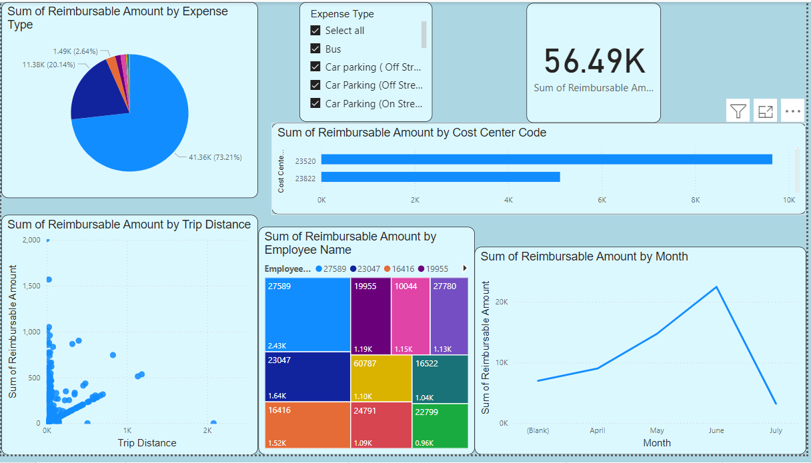

Figure 1 Expenses Dashboard

**Key Findings**

1. **Expense Distribution:**

Mileage Car – Total reimbursed amount of mileage is the highest compared to other categories of expenses, marked in the Pie Chart. This points to the fact that there will be a significant concern on the cost of business travels.Hotel charges also form fairly large proportions of the total expenses.

1. **Reimbursement Trends:**

In the Line Chart, reimbursable amounts touch the highest in June 2024 and a huge decline in July 2024. This is likely to show some seasonality or change in expense behaviour.

1. **Employee Claims:**

The Treemap reveals the fact that some of the employees reported significant reimbursable amounts in comparison with the other employees. This may mean that they are receiving high value claims or often present claims from the service providers.

1. **Cost Center Impact:**

The Stacked Bar Chart shows that not all cost centers have high reimbursable amounts; specifically, Cost Centre code 98429 implies specific whatever department or project has high costs.

1. **Expense Correlation:**

Looking at the aspect of reimbursable amount and trip distances in the Scatter Plot, there ranges in high levels of reimbursable amount, which implies that some amounts are very high even for small distances. This implies that the actual distance which is being traveled during the trip is not always an accurate measure of the amount of reimbursement to be made.

1. **Overall Reimbursable Amount:**

The actual claim on this account is £56,492, which available for reimbursement. 61, thus, offer insight over the total cost claim that can be processed as seen at a glance.

### Assessment of Accounts receivable Data

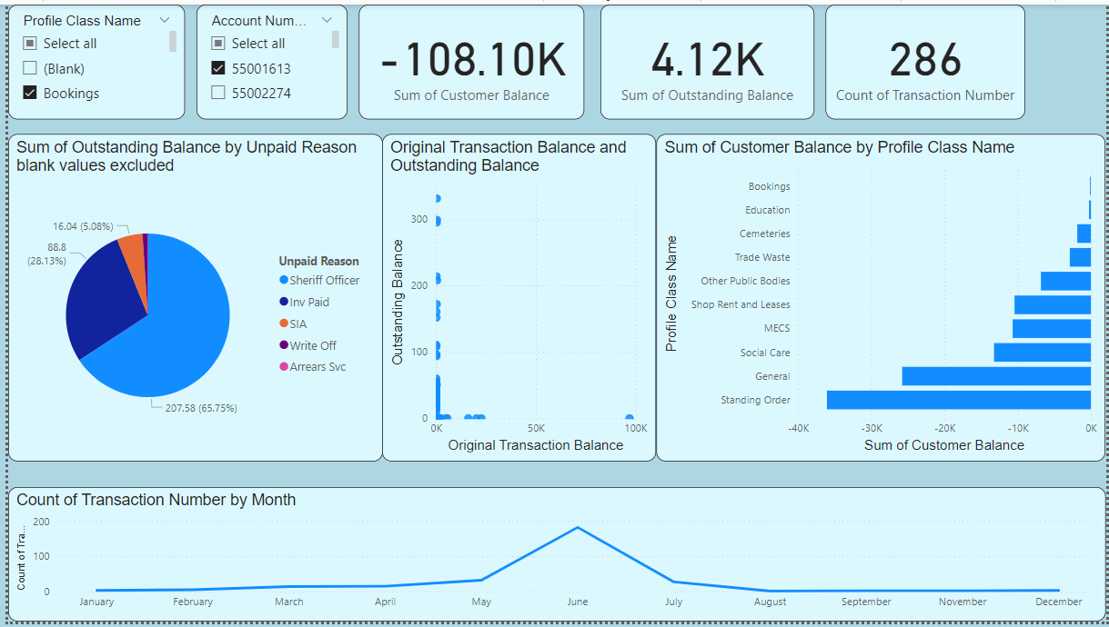

Figure 2 Accounts Receivable Credit Dashboard

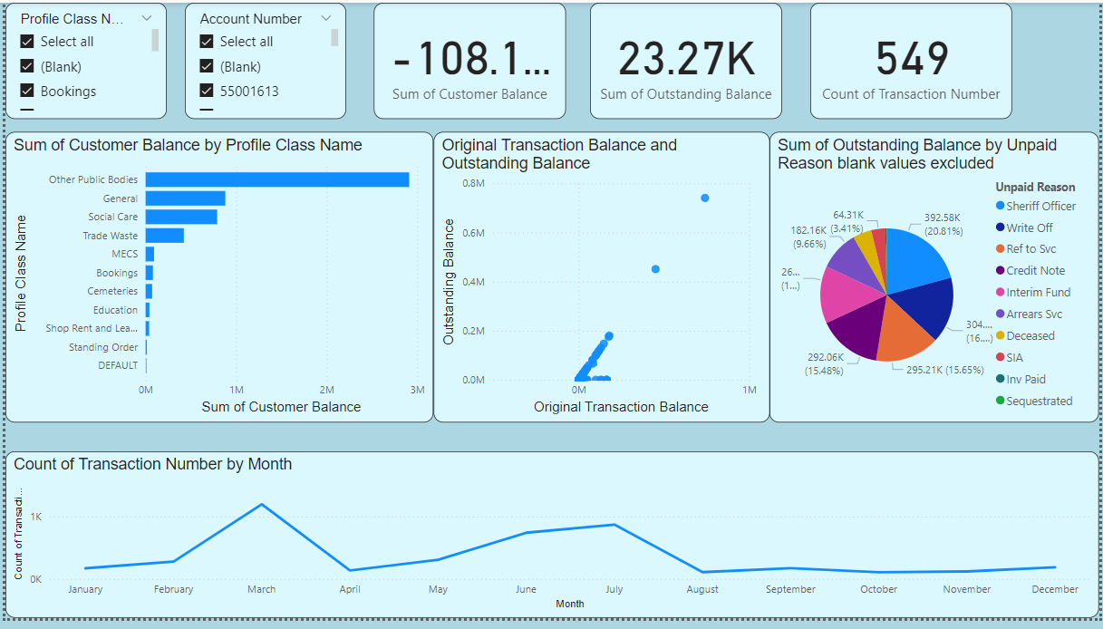

Figure 3 Accounts Receivable Debit Dashboard

**Key Findings**

1. **Unpaid Reason Distribution:**

From the credit report Pie Chart below it is evident that the outstanding balances have large portions being contributed to by “Sheriff Officer” and “Inv Paid” hence implying that these factors explain the balances that are overdue. In this debit report, the two main categories are “Sheriff Officer” and “Write Off” and looking at the percentage, large outstanding balances are as well associated with these reasons.

1. **Balance Trends and Correlations:**

From the credit report we note that the scatter plot of outstanding balances also shows a broad spread of the curve, meaning that many transactions tout the outstanding balances equal to zero, even though the original amount of transaction may vary widely. This means that a good number of transactions are cleared within the same period or soon after it was conducted. However, the debit report has the original transaction quantity and average outstanding, balances more spread out implying more variability and unaddressed transaction problems.

1. **Profile Class Financial Impact:**

In the Clustered Bar Chart, from the credit report, labeled: “ Negative Customer Balance”, ‘ Standing Order” and “Social Care” have the highest rate. Likewise, the debit report reveals that “Other Public Bodies” and “General” have the largest positive balances meaning that these profile classes have a large financial effect, either as a collector or obligee.

1. **Transaction Volume Trends:**

From the Line Chart for the credit report, one is able to infer that June registered the highest number of transactions, which could have been as a result of increasing activity, or other circumstances peculiar to that month. The line graph in the debit report reveals that the month of March received the highest number of transactions, which an additional high traffic period, but with higher volatility in the number of transactions during the year.

1. **Overall Financial Summary:**

For the credit report the total customer balance in the current account is -£108,117. 08 has an outstanding balance of £23,270.81 only which has been totalled. and 549 transactions. Customers’ total balance according to the debit report is way much higher with £5,343,623. 65 and an outstanding balance of £ 5,368,864. 88 across 4,400 transactions. These figures clearly depict that there are more of financial extravaganza and the amount outstanding mentioned in the debit report is much higher compared to the credit report.

In conclusion, it can be stated that the both reports have consider outstanding balance and transactions, but the debit report represent much more amounts of various operations and outstanding amounts. According to both reports, the former reveals that specific unpaid reasons and the latter reveals that certain profile classes that have relevant large coefficients have essential roles in the observed financial differences.

### Assessment of Daily Account Balances Data

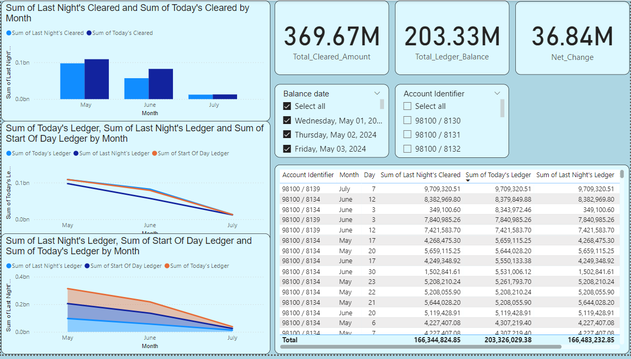

Figure 4 Daily Accounts Balance Dashboard

**Key Findings:**

1. **Monthly Ledger Variations:**

May perhaps record the highest values for all the ledgers in an organization’s books. In particular, the amount of ‘Today’s Ledger’ reaches £ 108,464,723.05 its considerably above the number obtained for other months of the year. July however, recorded the least figures with ‘Today’s Ledger’ totalling to £12,740,855.90, which is 751.31% down from May.

1. **Trends in Ledger Balances:**

In the monthly analysis data presented by the line chart, 'Today’s Ledger’ experience a peak in May followed by a decline in subsequent months. This decline is maintained through June and July which suggests either periodicity or alterations of account behaviours. Because ‘Today’s Ledger’ is positively related to ‘Last Night’s Ledger’ this means that greater values for ‘Today’s Ledger’ go with greater values for ‘Last Night’s Ledger’.

1. **Comparative Ledger Analysis:**

The stacked area chart further shows that May tops in ‘Today’s ledger’ and is equally reflected high in ‘Last Night’s Ledger’, ‘Start of Day Ledger’. This is quite tempo with June and July where the below figure totals the ledgers amounts are considerably inferior. The following chart shows a high degree of a direct relationship between the ‘Today’s Ledger’ and the ‘Last Night’s Ledger,’ in that, larger figures in the former are frequently accompanied by similar magnitudes in the latter. June also gives the biggest difference between the cleared amounts with ‘Today’s Cleared’ and ‘Last Night’s Cleared’, indicating variation in the cleared amount of June.

1. **Detailed Data Overview:**

The table provides a detailed look of all the account balances grouped under ‘Account Identifier’, ‘Balance date’ among other aggregated balances. May may still be, in fact, a rather large percent of the total ratios, namely 53.35% of 'Today's Ledger'. Table data also reveal that May recorded the highest number in ‘Last Night’s Ledger’ and ‘Start Of Day Ledger’. The difference between the two cleared amounts is one of the biggest in June with ‘Today’s Cleared’ higher than ‘Last Night’s Cleared’ by £ 25,227,429.11.

These insights provide a comprehensive understanding of the fluctuations in account balances over the observed months, highlighting May as the period with the highest activity. The analysis also reveals important correlations and variations in ledger balances, offering a clear view of monthly financial trends and discrepancies.

### Assessment of HR Helping Desk Data

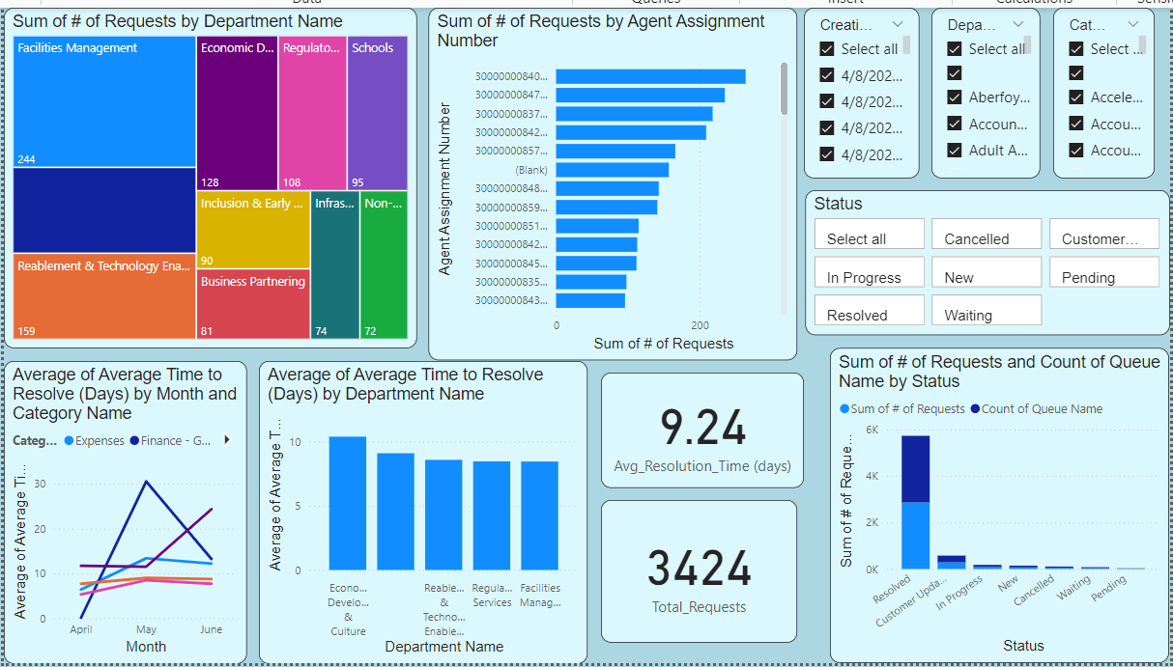

Figure 5 HR Helping Desk Dashboard

Key Findings:

1. **Request Distribution:**

Finance – General Ledger in May was 18.29% out of the total targeted goal. Resolved issues had been reduced by twenty nine percent of the average time needed to resolve them. This category has a significant effect on overall throughput dynamics, which evidences the fact of workload focus in this segment. Among all the requests the highest number was completed by the agent 300000008405020 – 264 requests, which is 7.71% of the total. The quantity of requests provided to the specific agent varies from 1 to 264, so there is the workload difference among the agents as well.

1. **Resolution Time Trends:**

In May, Finance – General Ledger also contributed 17.93% Avg resolution time is reduced by 93 percent. Several request counts are visibly different among agents; the data also shows that 300000008405020 received the largest number of requests, which was at its highest in the day. Bearing that in mind, we can scroll the queue names’ count up and down in parallel with the set number of requests, which evidently means that more requests may cause more problems in queues.

1. **Workload Analysis:**

300000008405020 remains the variable with the highest requests in comparison with other metrics of the site. This has an indication that this agent might spend more of his/her time handling work than other agents. The distribution of the overall request volume is rather skewed, which means that certain agents respond to significantly larger amounts of requests than others.

1. **Correlation and Impact:**

There is a positive correlation between total numbers of requests and number of queue names, which confirm that agents who receive more requests handle more problems. This correlation should point to the necessity to distribute requests evenly to reduce the pressure on the individual agents and to enhance the performance.

The 'HR Help Desk' dashboard reveals key insights into request distribution and resolution times. The concentration of requests in specific categories and among certain agents indicates areas where process improvements and workload management strategies could be beneficial. The significant volume handled by 300000008405020 and the variability in request distribution among agents suggest that addressing these issues could lead to more effective handling of help desk requests and better overall performance.

### Assessment of Invoice Data

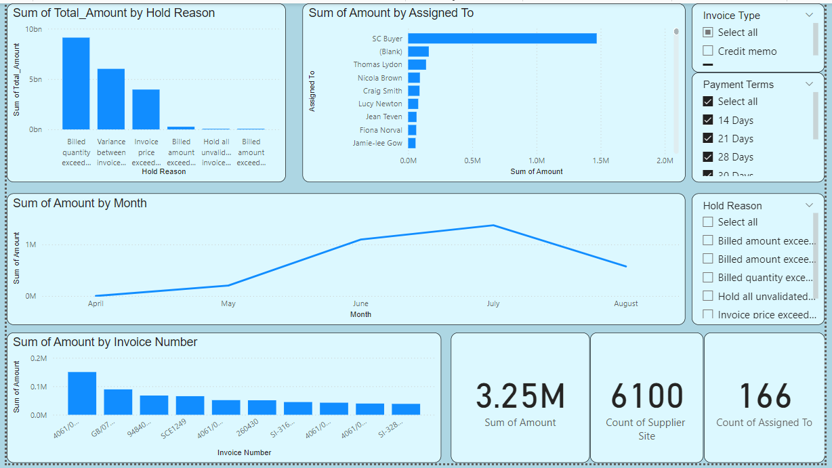

Figure 6 Invoice Data Dashboard

Key Findings

The invoice data analysis reveals key insights into financial discrepancies, individual responsibilities, and temporal trends in invoicing. Significant discrepancies are identified in categories such as "Billed Quantity Exceeds Received Quantity" and "Variance Between Invoice and Schedule Amount." These categories reflect substantial financial amounts, with "Billed Quantity Exceeds Received Quantity" totaling { £1,325,152.26} and "Variance Between Invoice and Schedule Amount" at { £838,902.57}. Addressing these discrepancies can enhance process accuracy and improve the invoicing system.

The distribution of financial responsibility among individuals varies notably. For instance, Aileen Powell manages the highest amount of{ £19,341.07}, while Aimee Howarth handles {£53,477.69}. This uneven distribution suggests a need for review and adjustment to ensure equitable workload allocation and operational efficiency.

Temporal trends indicate that July is the peak period, with the highest Sum of Amount at {£1,373,041.20}. This amount is approximately {572.50%} higher than the lowest month, April, which has a Sum of Amount of{ £240}. July accounts for{ 42.31%} of the total Sum of Amount across the months analyzed. This peak suggests a need for enhanced financial planning and resource allocation during high-activity periods.

High-value invoices, particularly those processed in July, should be closely monitored to ensure accuracy and timely handling. This focus on high-value transactions can help manage significant financial impacts and preempt potential issues.

In summary, the analysis provides valuable insights into invoicing discrepancies, responsibility distribution, and temporal trends. Recommendations include improving process controls, adjusting workload distribution, planning for peak periods, and closely monitoring high-value invoices to optimize financial management and operational efficiency.

### Assessment of Mailbox Data

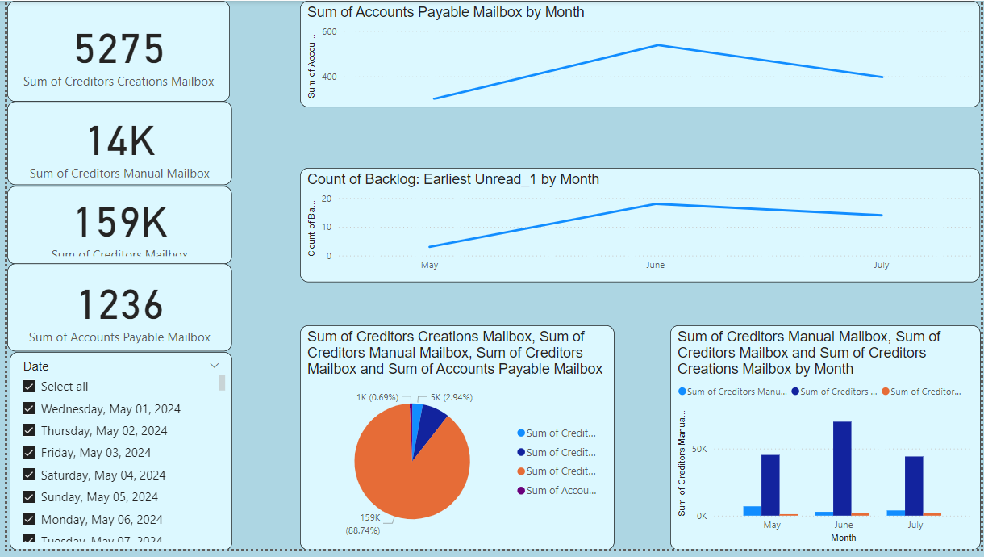

Figure 7 Mailbox Dashboard

Key Findings

The line chart of the sum of Accounts Payable Mailbox reveals that data of June has the highest sum of {538} and the other 2 sums of Accounts Payable Mailbox in May and June are much higher than the accounts in July. In particular, May’s sum was {301} while the second highest sum of June increased with {78.74 %} more than May. According to the outcomes of the research, June accounts for {43. 53%} of the whole sum of money for the accessible months. This is a leading note in June only to imply that there may have been certain events or activities in this month that saw an augmentation in number of accounts payable. The fluctuation in the data also indicates the need of analyzing further the monthly movement to inspect whether there is a pattern or not that may impact on the finance sector.

In contrast, the line chart for Backlog: The first time a user opens the application, it can be seen that there is alot of {NaT} data which is missing making Earliest Unread to present a challenge. This has the rather bad effect of creating inconsistency in data availability, therefore reducing the capability of trend analysis. However, the chart depicts that the most often repeated backlog date was {June 24, 2024} which was recorded {16} times in the dataset. from this it is plausible that June records a higher backlog of entries but due to inadequate data, more information and analysis can’t be determined.

The pie chart concerning the mailbox categories shows an appropriate division of values by categories. Again, the Creditors Mailbox category tops the list in terms of the total value with {159, 414. 0} as seen below; The mailboxes that are closely related to the Creditors Manual Mailbox are Creditors Creations Mailbox and Accounts payable mailbox and they have relatively low activity scores of 5,275. 0 and 1,236. 0 respectively. This distribution also shows that the share of Creditors Mailbox is the highest among the others, so this shows that this category receives a significant percentage of the total of this kind of transactions because this mailbox could be very important in terms of the volume of transactions or financial flow at a particular organisation.

Overall, the analysis of the data highlights key periods of activity and the relative importance of different mailbox categories. The high values recorded in June for Accounts Payable Mailbox and the significant proportion of Creditors Mailbox among categories suggest areas that may warrant further investigation to understand underlying causes and implications. The inconsistent data for the Backlog: Earliest Unread category points to potential data quality issues that could impact the ability to make informed decisions.

### Assessment of Revenue Monitoring Committee Report Data

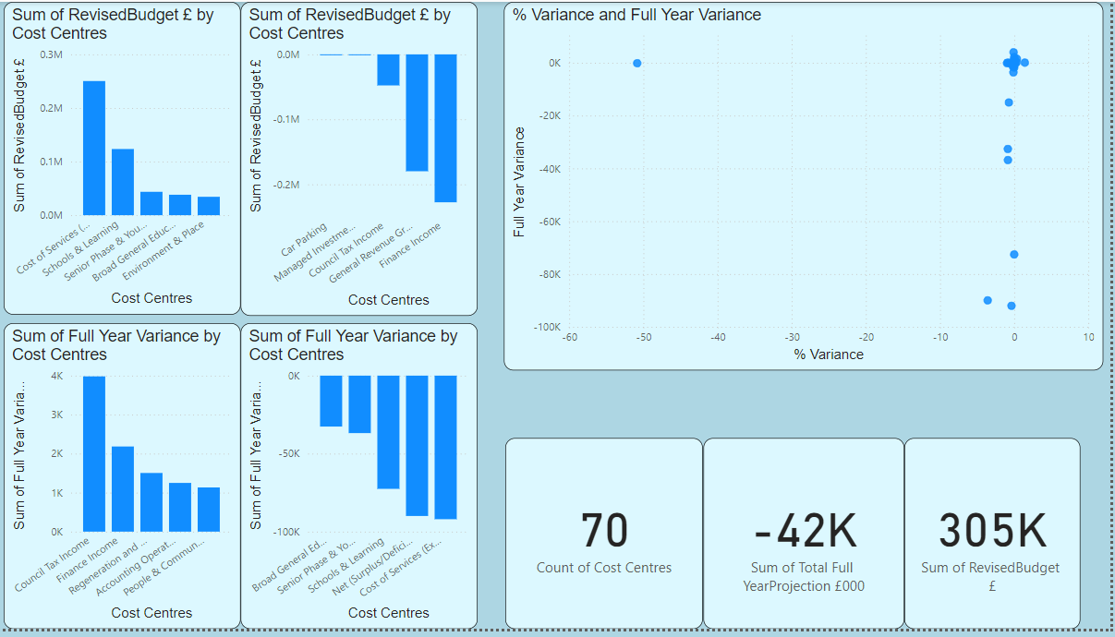

Figure 8 Revenue Monitoring Committee Report Dashboard

Key Findings

The stacked column chart for sum as Revised Bu{ £250,247}. This value was considerably greater than the minimal total identified in the five most costly zones – Environment & Place which equalled {£34,329}. More specifically, Cost of Services (Excluding HSCP) occupied {51. 09%} of the total revised budget £ of all the cost centres identified above. It is evident from the data that the overall Revised Budget £ varies with respect to cost centres for a range of {£34,329} to {£250,247} depicting disparity in financial magnitudes at cost centres level.

On the other hand, the stacked column chart of the bottom {5} cost centres of the Revised Budget £, is as follows; The negative sign here indicates cut backs or lower budgetary provisions. The negative sums in the bottom {5} cost centres general of which are General Revenue Grant & Non Domestic Rates Income and Council Tax Income reflect a trend of under-funding or adjustments that has trimmed their budgets substantially. The variation in budget allocations from -227,603 to -53 clearly showed that the level of variation is severe.

Analyzing the clustered column chart, for Full Year Variance it can be noticed that Council Tax Income was by far the highest at {£3,981} meaning that the council performed well better or received more than expected in this receipt head. Other main cost drives comprise Finance Income and Regeneration and Economic Growth implying positive variances of {£2,183} and {£1,504} severally. These positive variances show areas which are doing even better than estimated or calculated financial performance

On the other hand, the clustered column chart of the bottom {5 }cost centres by Full Year Variance is as follows: Cost of Services (Excluding HSCP) with the lowest variance at{ -£92,037}. This large negative variance indicates large budget under-estimations or over-expenditures. Other Related cost centres such as Net (Surplus/Deficit for Year (Excluding HSCP) and Schools & Learning also depict massive negative variances implying weaknesses in the management of the organization’s budget.

The % Variance scatter plot involves the use of descriptive statistics in which the average % Variance equals {-0.92%} while the range is between {-50. 84% and 1.43%}. This gives the impression of a negative variance nature within all the cost centres and huge fluctuation. The mean Full Year Variance is equal to {-£5,335} while the variance coefficients range between {-£92,037} and {£3,981}. The relatively high standard deviation reveals that there is wide dispersion of the cost centres’ financial performance.

As a result of the analysis, important budget differences and fluctuations in cost centres are demonstrated. Greater accuracy in the top cost centres and negative values in few other cost centres indicate they are potential areas that need further analysis of nature of financial fluctuations. The fluctuation in % Variance and Full Year Variance explains that there may be issues regarding budgeting or making accurate forecast in the future.

### Assessment of Customer Accounts Aging by bucket List Data

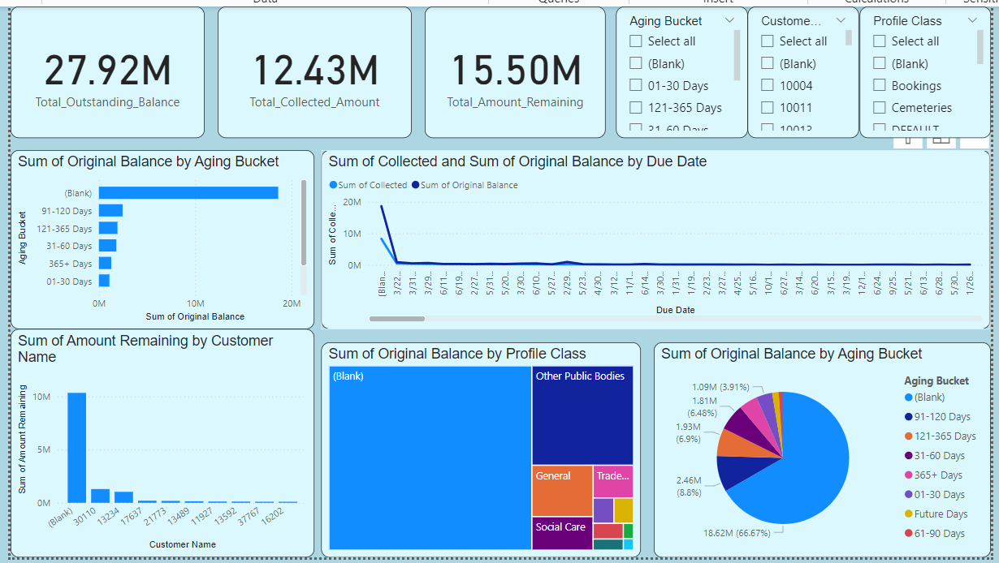

Figure 9 Customer Accounts Aging by bucket List Dashboard

Key Findings

**Stacked Bar Chart:**

From the above data, the {91-120} Days bucket has the highest sum of the original balance were £2,458,639. 20, which is much higher than the {61-90} Days bucket that has the least balance of £292,358. 15. This shows the existence of a large variance of balances in different aging categories. The differences in the overdue claims can be seen from £292, 35. 15 to £2, 458, 639. 20.

**Pie Chart:**

I fondly refer to this distribution as the Aging Bucket Distribution because the cumulation of the booklet probabilities result to different aging bucket probabilities.

When pie chart is being read it further supports the interpretation given by stacked bar chart saying {91-120} Days has the highest percentage of the total original balance. This distribution implies that a huge proportion of the balance is held in the overdue buckets particularly {91-120 Days} that would be an area of focus for the debt collection drive.

**Clustered Column Chart:**

Lists of Customers that have remained within the top ten for Amount

At the top is Customer {30110} who owes {£1,290,883. 72} where there is a big difference between the first top {10} customer and the last, Customer {6079}, with outstanding of {£97,172. 20}. Range of the outstanding top {10} customers indicate significant variation and areas that could be targeted for collections.

**Treemap:**

The profile with the largest original balance is Other Public Bodies {£5,022,004. 18} which is way huge as compared to the balances of other profiles. The lowest balance of all the five categories is Cemeteries with balance of { £262,186. 55. } This balance distribution indicates that about all the balances are concentrated in a few accounts signifying that there could be potential big hit accounts in financial management exercise.

**Line Chart:**

The line chart also depicts that the total amount collected and the initial balance is high-volatile during the year. Some balance figures exceed the collected amount implying at some point, the firm has recorded a large collection deficit. This indicate that company receive lesser collections compared to the balances due as time goes on.

### Assessment of Absentees Data

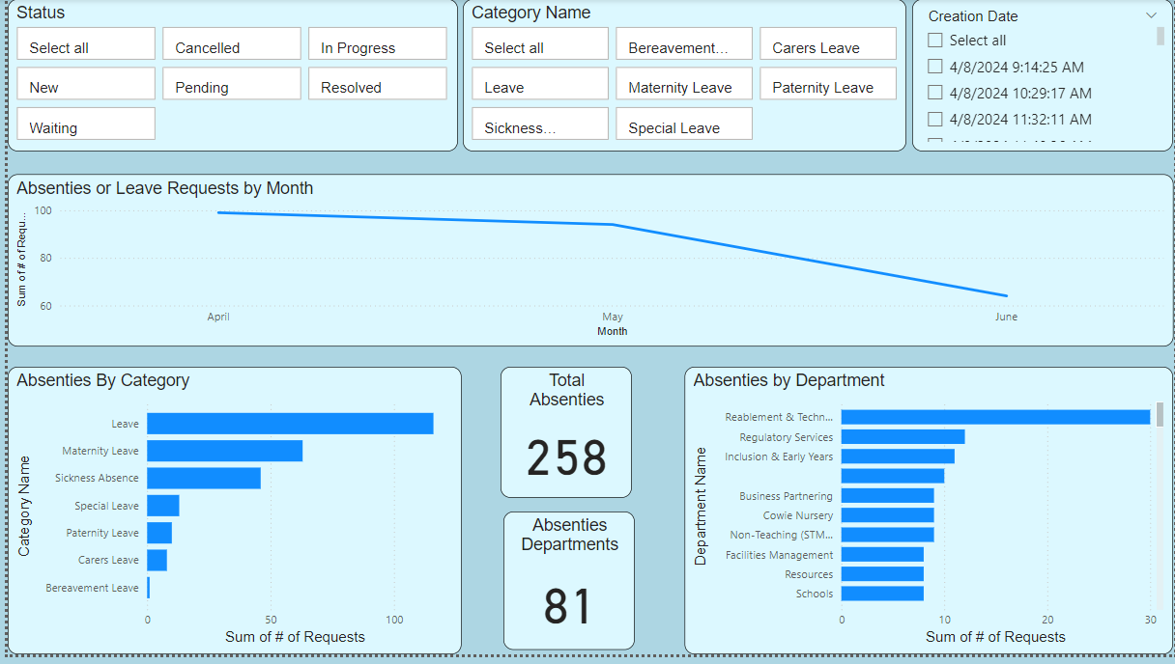

Figure 10 Absentees Dashboard

**Filtered Data Summary**

The data includes 257 records selected with the help of categories concerning different kinds of leave and absence. The structure of the dataset hence contains features such as RefNo, Queues, Categories, EmpID, JobNames, Department, DateCreated, AvgResolveTime, and Requests.

Key Findings

**P Bar chart of Stacked type according to the Category Names**

**Category Distribution:**

* Leave: 116 requests
* Maternity Leave: The current average of ID requests is of 63.
* Sickness Absence: 46 request
* Special Leave: 13 requests
* Paternity Leave: Ten, ten
* Carers Leave: 7 requests
* Bereavement Leave: It was felt that one request would be enough to get a response from the implementation of the pedagogy in schools.

**Insights**:

* The “Leave” category is the most popular, many more requests were made in it in comparison with other categories. This shows that this is the usual kind of request that is that made out there.
* “Maternity Leave” and “Sickness Absence” come next in terms of their frequency and this shows a high traffic of requests in these categories.

**Bar Chart-1 based on Department Name & Organization of stacked bars**

**Department Distribution:**

* Reablement & Technology Enabled Care: Selected values of thirty requests
* Regulatory Services: Twelve is the number of requests that has been embedded below the deadline call:
* Inclusion & Early Years: Fifty-five request were made to full-fill the fore mentioned eleven requests in the follow-ups and subsequent correspondences.
* Business Partnering: 9 The letters which were made contain nine requests.
* Non-Teaching (STMHS): nine Defensive requests

**Insights:**

* For greater details, let’s look at the request volumes by departments: The highest count was in “Reablement & Technology Enabled Care”, so it may have the most leave management activity.
* A trend that can be observed is that many departments receive few requests while some departments receive a much higher number of requests. This could mean that there exists some inequity in the administration of leave more especially between departments.

**Products as per creation date has been illustrated in the following Line Chart:**

**Requests Over Time:**

The frequency of requests does not follow any pattern and is nearly the same for all the days of the week.

**Insights:**

* The fixed count of the request as regards the date shows that requests are equally dispersed over the time period with no sign of fluctuation.

**Overall Summary**

**Category Analysis:**

* The “Leave” category is undoubtedly one of the most popular with a high average of the number of requests as compared to other categories.
* Maternity Leave and Sickness Absence indicate substantial amounts probably necessitating a closer analysis of this nature of attendance strategies.

**Department Analysis:**

* Some departments receive significantly higher number of requests than the others. This may shed light to some disparity in terms of workload and these organizational policies on leave that should ideally be looked at more closely.

**Temporal Analysis:**

* In terms of the distribution of requests over time, theirSmoothing out of requests means that there will be a rather stable request rate, though it might also mean that one should perform finer time-based analysis to discover a pattern or a trend if there really is any.

### Assessment Sickness Absentees Data

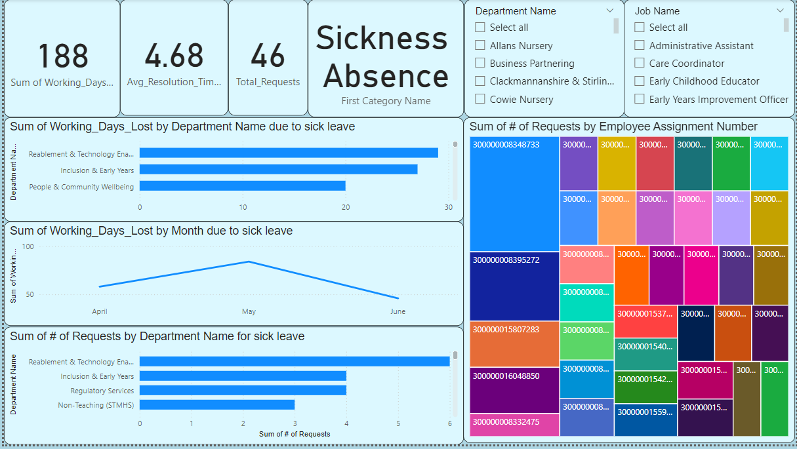

Figure 11 Sick Absentees Dashboard

Key Findings

**Working Days Lost Trend (April to June 2024):**

Specifically during the period of observation from April to June 2024 there was a fluctuating trend in the working days lost. The working days lost dramatically increased in May, which has thirty four days in total and contributing [44.68%] to the total working days lost in the study period.

On the other hand, the employee turnover was low in June with the company losing working days through employee turnover of [46] days which is 82. 61% less than what was recorded in May.

April is a bit more moderate and registered 58 working days lost, which are mid- between May and June. This is followed by more-than-average number of absentees in the middle of May and much lesser in the second half of June which may be because of events/seasonality.

**Departmental Requests and Absenteeism:**

Further, the breakdown of requests by the department indicated that the issue of absenteeism cut across all the departments as some of the departments such as ‘Inclusion & Early Years’ and ‘Regulatory Services’ had higher values of ‘working days lost’. But, more than 90% of these departments captured only a few requests. This distribution also implies that although absenteeism is a more generalized problem, some departments need to be addressed individually because of high numbers of absenteeism.

**Individual Employee Requests:**

In terms of individual employee data, most employees recorded a single instance of absence. However, there were outliers, such as an employee with assignment number [300000008348733], who had [5] requests, indicating repeated instances of absence that could warrant further investigation.

Summary statistics on employee absenteeism show that on average, employees recorded [1.21] requests, with a maximum of [5 ]requests, further underscoring the need for individualized attention in certain cases.

**Resolution Time and Working Days Lost:**

The average time to resolve absence-related issues across departments was [4.68] days. This metric is crucial for measuring the efficiency of the HR department or the process flow of absence-related matters. The maximum time recorded for resolving an issue was [27.22] days, with significant variation (std = 7.23), pointing to inefficiencies that could be optimized.

## Conclusion

The study conducted in chapter four provides a macro understanding in financial and operational unusual activities in costs centres, aging balances to customers and other debts and patterns of absenteeism. When looking at the Revised Budget £ data It is possible to decipher that budgetary dispersion is a reality where there are a lot of differences between cost centres in terms of budgets and financial performance. Some of the largest cost centres include Cost of Services (Excluding HSCP); these have a large budgetary magnitude suggesting substantial monetary devotion and resource expenditure. On the other hand, the bottom cost centres shows tendency of underfunding or budgetary changes even though there is negative variance it is more apparent on Finance Income cost centre. The contrast shown in the above simplified example explains why accurate analysis of the causes for certain differences in the sum of money should be looked for thoroughly so as to magnify whether it was attributed by a change in needs, emergence of costs that had not been foreseen before, or other kinds of issues related to the financial management process.

Further, the scatter plot of % Variance with Full Year Variance indicates mainly the negative variance within the cost centres signifying the huge variability or, possibly problems with the forecasting of the financials or management of the budget of various centres. That variance on the cost centre scale is much higher than the overall variance implies that, while some cost centres might be doing just fine according to their financial projections, others are lagging way behind, this might hint at the fact that the cost centres need to be realigned strategically or the budgetary controls improved.

Aging and balance data analysis provides additional insights on some of the fundamental issues to do with debt collection and financial management. The big figures highlighted in the 91-120 Days aging bucket, we see that there is a significant opportunity to drive collections and increase liquidity by improving collection from the bigger balances which seem to be overdue. As much of the outstanding balances appear in these areas, a rational approach to the debt collection is to concentrate on accounts with greater balances and the buckets containing overdue amounts to enhance the company’s financial situation.

# Chapter 5 – Conclusions, Limitations and Recommendation

## 5.1 Conclusions

This case study was to assess the impact of Stirling Council’s Oracle Fusion Cloud and its efficiency in terms of financials, operations and staff. the analysis process entailed the examination of diverse sets of records within the organization such as the accounts receivables, costs, daily account statements, help desk information, invoices and revenues. Hence, the goal of this work was to analyse key financial ratios and VC trends from the position of getting a better understanding of financial tendencies and possible improvements in the company’s operations.

Throughout the analysis, several key findings emerged

### Financial Performance:

Among the data analyzed within accounts receivable there was identified several trends concerning outstanding balance and unpaid causes. Some of the customers’ characteristics were identified as having higher outstanding balances at a certain period than at others, which implies that an effective collection strategy should be more focused. There was also a good mapping between transaction balances at the time of origination and outstanding balance that highlighted areas where more efforts must be put in to recover the amounts that have got to some extent to be overdue.

### Expense Management:

The review of expense reports was useful for purposes of determining reimbursable amounts, type of expenses and cost centres. The visualizations later presented different spending distribution and showed sites with more reimbursable costs. These findings call for a more attention to the issues that require more control and possibly budget modifications to maintain a more positive control over a firm’s expenses as well as financial objectives.

### Daily Account Balance Monitoring:

When reconciling the account balance, the daily analysis provided the understanding of the ledgers and the cleared amounts. The changes in the balances of ledgers were illustrated vividly and the fluctuations pointed at months that recorded more financial transactions. This information is important to the company to deal effectively with problems that may arise on the financial front as well as for reporting the status of these assets properly.

### Aging and Balance Data:

Evaluation of aging and balance distributions clearly showed that there are significant differences not only between different ‘buckets’ of aging, but also between different customers. The analysis of distribution revealed that the majority of overdue money was in the range of 91 to 120 days, which pointed at their high balance. The research points to the exact nature of collection process and effective collection of outstanding balances.

### Help Desk and Absenteeism Data:

Help desk data demonstrated patterns of working days lost, volumes of requests received across departments and time taken to respond to these requests in cases of absenteeism. It was observed from the data that there was an increase and decrease in the level of absenteeism particularly spike and changes in levels across different departments. Moreover, the findings of the absenteeism data analysis highlighted the issues of more effective management of resolution processes and use of targeted approaches with reference to departments having high levels of absenteeism.

Altogether it gives the evaluation of the financial and operating efficiency in the case of Stirling Council. The research findings can enable organisation to focus improvement efforts where it can be achieved; improving total collections, better approaches to expense management and managing or responding to increased volume of absenteeism. Despite the limitations that have been encountered it is very useful in making future decisions and enhancing the usability of the ERP system.

## 5.2 Limitations

Some of the limitations arising when doing the analysis include, limitations that arise in the choice of results, limitations that arise in the methodology, and general limitations in the findings. Knowledge of these considerations is essential in order to ensure that the results of the analysis are meaningful and to determine where additional study or additional data may be needed.

### Data Integration Challenges:

One of the major challenges faced while undertaking this particular study was the fact that data could not be cross tabulated properly across different files. The provided samples of accounts receivable, expenses, daily accounts balance, HR help desk, invoices and others were mostly unlabeled or did not share variables which can let integrate them accurately. This fragmentation made it difficult to analyze the data from one dataset with another which is important when determining some of the KPIs. Specifically:

**Absence Rate (%) by Department:**

The absence data could not be charged to particular departments because there were no eployee count by department in these records. Thus, it was impossible to determine the % of working days lost to sickness in each of the departments.

**Cost of Absenteeism:**

Some of the financial information required when putting a price tag measure to employee absenteeism such as total salaries cost and other related expenses were lacking. Regarding this, the calculation of the cost implication of the level of absenteeism in the organization was not possible due to this limitation.

**Full-Time Equivalent (FTE) Impact of Absences:**

Absence records and employee work schedules were not well aligned through the datasets and it is these records that are central to converting absence days to FTE capacity lost. Such exclusion limited the possibility to evaluate potential real operational effects on the staffing levels.

### Data Quality and Completeness:

The datasets provided also presented issues related to data quality and completeness:The datasets provided also presented issues related to data quality and completeness:

**Missing Data:**

Some of the datasets included some blank or incomplete entries was noticed. For instance the records at the HR Help Desk were inadequate in that specific areas such as the assignments of employees and most importantly, the resolution time for each case was not well documented. Lack of relevant data can raise the issues and concerns on the validity and accuracy of the findings.

**Inconsistent Data Formats:**

Different datasets utilized varying formats and units of measurement, which complicated the consolidation and comparison of data. For instance, expense reports used different formats for dates and amounts, making it challenging to perform time-series analysis and financial comparisons

### Limitation in Methadology

The methodologies employed in this analysis were constrained by the available data and the nature of the datasets:

**Descriptive Analytics Focus:**

Due to these constraints it was not possible to carryout extensive statistical analysis; therefore the study mainly employed descriptive statistics and graphs. These methods were useful in offering insights about phenomena, but often more elaborate analyses like predictive modeling, which could provide a causal understanding and suggestions were lacking.

**Lack of Longitudinal Data:**

The results obtained were done with cross sectional data from unique periods. It would have been more helpful if cross-sectional data, which capture information at one given time, had been replaced with the longitudinal data which offers changes in a given period of time. The lack of such data also presented the problem for time-based effects and trends examination.

### Constraints in Data Availability

The scope of the analysis was inherently limited by the data that was available:

**Financial and Operational Data Gaps:**

Some of the important financial and operational figures required to carry out a detailed analysis of the budget and its effects on financial and operational resources was absent. This included: analysis of expenditure for service delivery and absence related costs.

**Absence of Benchmarking Data:**

Unfortunately, the study never had benchmark data that would allow one to see how the Stirling Council stands in comparison to other similar organizations. Some of such benchmarks could have offered more information about the performance of the Council and areas that required overhaul.

### Interpretative Constraints

**Assumptions and Generalizations**

Because of lack of a single comprehensive database, there were several assumptions made during data analysis, that are enumerated as follows; For example, assumptions on financial implications or trends in truancy were made as a result of limited information hence implying on a possibility of biasness in the conclusions made.

Collectively, these limitations mean that there are significant difficulties for such analysis due to the data sources themselves, the nature of the data and the methods that can be applied. In the future work it is suggested to pay more attention to the data integration, data quality, and possibly use more sophisticated methods to have a better evaluation of the performance and efficiency of the Council.

## 5.3 Recommendations

Several important recommendations have been made on the basis of analysis of the ERP data provided by Stirling Council to address different business problems and to improve efficiency of operations. These recommendations are intended to target some interested problems concerning financial management and expenses, auditable receivables collection, and employee turnover, as well as considering some changes in aspects of the ERP system.

### Strengthen Debt Collection Strategies:

**Recommendation:**

Check customers who have regularly high outstanding balances and design and/or enforce specific mechanisms for collecting balances from such customers. This includes:

**Segmentation:**

The customers should be firstly grouped and differentiated by the records of the amount outstanding and payment behavior.

**Customized Collection Plans:**

Develop specific collection plans for such high-risk customers by including more stringent and forceful collection follow-ups and other strategies.

**Regular Monitoring:**

It is recommended that, set up a routine follow up mechanism with checklists of which accounts are due and then control and change collection techniques if necessary.

**Business Impact:**

Efficient and effective measures to collect debts will result in the reduction of balances, better cash flow and minimization of bad debts thus improving the position of the Council’s financial.

### Optimize Expense Management:

**Recommendation:**

Optimise spending controls with reference to resource utilisation plan, working expenditure targets etc.

**Expense Tracking:**

Scan for increased specifics about reimbursable costs at cost and employee level specifically targeting important reimbursing accounts.

**Budget Reallocation:**

Relocate budget needs based on specifics of the analyzed expenses and reposition funds to precisely heading areas while possibly finding ways of making expenditures in the organization.

**Expense Approval:**

Improve and optimize the expense approval to eliminate down sides that are involved in the validation of the claims such as errors and fraud.

**Business Impact:**

Efficient spending will make work efforts better in price control and reducing expenses by making efficient use of funds.

### Improve Financial Stability through Enhanced Balance Monitoring:

**Recommendation:**

Enhance daily control of accounts balances and ledgers changes:

**Enhanced Reporting:**

Generate separate and more frequent reports to distinguish daily ledger balances and cleared amounts so as to rectify any irregularities on time.

**Trend Analysis:**

Many businesses prefer to analyze the trends to help predict peaks of their financial flow and thus regulate them in order to stay financially stable.

**Financial Controls:**

This shows that the finance department and the bank are not well-coordinated, hence recommending that tight financial controls and reconciliations should be put in place to deal with such changes and effectively analyze the financial status of the company.

**Business Impact:**

Financial balance will be well monitored, thus cutting chances of difference and erroneous planning as well as reporting.

### Address Absenteeism with Targeted Interventions:

**Recommendation:**

Analysing the problem of absenteeism, it is necessary to introduce effective strategies to address the problem and minimise its potential:

**Departmental Analysis:**

Analyse the number of employees who are frequently absent from work by their departments and discover possible causes for the same.

**Wellness Programs:**

Establish and advertise wellness tools to prevent cases of absenteeism taking into consideration departments that experience high levels of such issues.

**Resource Allocation:**

Decrease the working time of the employees of the departments with many absentees or redeploy some part of the human resources to meet the needs of the organisation.

**Business Impact:**

The strategy is to address absenteeism in an effective manner because it will increase workforce productivity, decrease interruption to operations, and increase the delivery of a better service.

### Enhance Help Desk Efficiency:

**Recommendation:**

Optimise the processes of working with the help desk and the identification of issues.

**Streamlined Processes:**

Optimize help desk functions so as to offer faster solution to the clients with a view of improving on the time taken to solve problems.

**Performance Metrics:**

Tactics performance indicators and evaluations of their requests’ processing time and efficiency.

**Training:**

Train help desk staff further for better problem solving in order to avoid or revert time taken to analyze the situations.

**Business Impact:**

Optimizing help desk performance will enhance satisfaction to the customers, minimize interruptions to operations and guarantee effective assistance to employees and services.

### Improve ERP System Integration and Data Management:

**Recommendation:**

Identify problems related to data integration/linkage within the ERP technical environment and design proper solutions in order to enhance their analysis and reporting functions:

**Data Integration:**

Improve integration of different source of data in the ERP system to address the issue of linkage as well as data connectivity before analysis. This is entails linking of the data concerning the financial position, records of employees, and the output of each department.

**Data Quality:**

Maintain the validity and accuracy of the system’s data by instituting data validation checks, as well as normalizing entry methods throughout the system.

**Common Variables:**

Define appropriate keys in each of the datasets and distinct identifiers for more ease in handling the several data sets.

**Advanced Analytics:**

Leverage enhancements in analytics technologies within the premises of perfetion to analyze data, model predictive and gather and report complex results.

**Business Impact:**

Optimization of ERP systems and data processing will lead to improvements in the quality and scope of financial and operational reports and, therefore, more rational resource usage.

Implementation of these recommendations will therefore help to solve some of the problems that have been highlighted in the analysis and help Stirling Council to improve on the efficiency of its operations while in the process attaining better results on both the financial and workforce management. The enhancements in the ERP system will provide a greater ability for establishing enhanced analysis, which in turn will allow for better organisational decisions and performance.

## 5.4 The Future

Before bringing this case study on the ERP data analysis for Stirling Council to a close, this paper looks at the future direction and possible further developments in regard to the Stirling Council and the council’s ERP system. From this perspective, it can be concluded that the analysis of current practices for the management of student groups has been helpful to gain insights into the ongoing processes, to reveal strengths and weaknesses of the approach, as well as to define certain difficulties. Next, we offer a set of directions for further development of operational efficiency and further potential for ERP capabilities enhancement.

### Embracing Technological Advancements:

It is obvious that the further development of ERP systems will be heavily influenced by such technologies as artificial intelligence, machine learning, and automation. The organization can also be able to improve on data analysis, automate the processes and have accurate forecasting if it is able to integrate these technologies into the ERP system. Interacting and applying these technologies will give an added advantage and will influence the choice of better proactive approaches and decision making.

### Continuous Improvement and Adaptation:

It is important to know that the environment of operations of public sector and practicing of financial management is very dynamic. In order for Stirling Council to maintain its edge it must introduce the organizational culture of ‘never being done’. It will be necessary to frequently review ERP processes, include users’ feedbacks, and make necessary changes according to the alteration in the legislation or the company’s requirements.

### Enhancing Data Integration and Analytics:

As for the future endeavours, it is advisable to concentrate on the improvement of data consolidation processes with the aid of different departments and data kinds. Greater progress in data matching with complete analysis will provide the better understanding and enhance the decision making and strategic plan in UK. New generation of data integration tools and continuous promotion of the data culture will also be vital for the success of ERP.

### Fostering a Data-Driven Culture:

Propagation of culture that approves quantitative analyses and organization’s operations is conducive for the sustainability of the ERP system. When staff handling specific orders is trained on how to analyze the data appropriately, when people are encouraged to embrace the use of the ERP tools and when the departments are encouraged to work hand in hand in the analysis of the insights, then the efficiency of the system and the extent to which the insights are used will be improved.

### Strategic Planning and Long-Term Vision:

Prescribing the direction for the future use and improvement of the erp system will aim at providing a framework for future activities and spending. Such objectives, milestones and measure of achievement for this plan should be defined as follows. Holding strategic long-term vision, the Stirling Council can better synchronize ERP projects with the general strategic objectives of the organization and maintain continuous improvement of organizational performance.

### Leveraging Feedback and Lessons Learned:

The knowledge that can be derived from this analysis should be utilised for future project and enhancement. Collecting feedback from the users and interested parties as well as analysing past experiences can provide improvements to the strategies that shall be applied and can improve the functionality of the ERP system. A submission of problems at the right time to allowed the success to be implemented will lead to a corresponding improvement all the time.

Thus, again, it is possible to state that, although the current analysis has given essential insights into understanding and solving major problems, improving the efficiency of ERP functioning and meeting organizational objectives is a never-ending process. In this context, it is possible to state that Stirling Council can continue the successes achieved in this project by adopting advanced technologies, maintaining a state of constant improvement, improving the integration of data, actively developing a data-oriented culture, and defining clear visions. It is for this reason that several prospects in extending the ERP effectiveness over the subsequent period are viewed as crucial to achieving the mandated objectives of the Council.

# Bibliography

<< ANY REFERENCES YOU WANT TO INCLUDE: REPORTS, PAPERS, TECH ARTICLES, ETC >>

# APPENDICES

<< INSERT HERE ANY APPENDICES YOU HAVE, EACH STARTING ON A NEW PAGE, WITH A NEW TITLE, AND APPENDIX MUMBER >>